NPVR
SMS Service
Detailed Design Document
Author: Chen Shuai
Version: 0.2
Date: 2006-10-16

Contents
1 INTRODUCTIN………………………………………………………………………..5
1.1 PURPOSE……………………………………………………………………….5
1.2 SCOPE...…………………………………………………………………………5
1.3 Definitions, Acronyms, and Abbreviations……………………………...5
1.4 overview…………………………………………………………………….….5
2 architecture………………………………………………………………………7
2.1 architectural goals and constraints………………………………….7
2.2 system logical structure………………………………………………7
2.2.1 Overview………………………………………………………………………...7
2.2.2 System Hierarchy………………………………………………………………..7
2.2.3 Architecturally Significant Design Packages…………………………...8
2.2.3.1 Common Module……………………………………………………..8
2.2.3.2 SMS-Gateway…………………………………………………………8
2.2.3.3 SMS-Modem…………………………………………………………..9
2.3 Error Handling and Fail-Over [optional]……………………………10
2.3.1 SMS-Gateway……………………………………………………………..10
2.3.2 SMS-Modem………………………………………………………………10
3 Static class view………………………………………………………………..12
3.1 SMS-Gateway Class View……………………………………………….. 12
3.2 SMS-Modem Class View………………………………………………….13
4. system sequence view………………………………………………………………14
4.1 SEquence diagram…………………………………………………………14
4.1.1 SMS-Gateway Sequence Diagram………………………………………14
4.1.2 SMS-Modem Sequence Diagram………………………………………..15
5. configuration…………………………………………………………..……… 16
5.1 SMS-Gateway configuration………………………………………………16
5.1.1 SMS-Gateway configuration in registry…………………………… ..16
5.1.2 SMS-Gateway configuration in config xml…………………………..18
5.2 SMS-Modem configuration………………………………………………...23
6. OBJECT DESIGN…………………………………………………………………………..25
6.1 Common Object……………………………………………………………..25
6.2 SMS-Gateway objecsts……………………………………………………...30
6.3 SMS-Modem objects ………………………………………………………..33

Revision History
Version | Revise Date | Owner | Notes
0.1 | 2006-3-1 | Chen Shuai | Initial document
0.2 | 2006-10-16 | Chen Shuai | Updated document

Introduction

Purpose
SMSService includes 2 versions which one is Gateway version and another is Modem version. SMSService is an important service in the framework of the NPVR of ZQ. However SMS-Gateway is based on Short Message Service Provider and SMS-Modem is based on GMS-Modem, but their logic work flows are similar.

Scope
This detailed design is based on the “Software Architecture Document” of this project.

Definitions, Acronyms, and Abbreviations
TM: Team Mark
SMSService: Short Message Service(Generally)
SMS-Gateway: Short Message Service Gateway version
SMS-Modem: Short Message Service Modem version

Overview
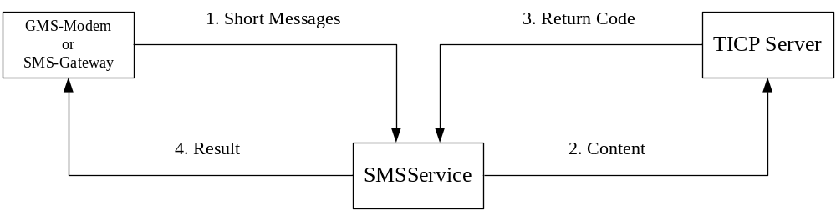

SMSService is a service application to receive short messages, process short messages, send the content to TICP, receive result from TICP and send result to TICP. At present, SMSService support 4 services including order, chat, register, nickname.
- Keep the communication between SMS-Gateway with TM through Internet or keep the communication between SMS-Modem with GMS Modem.
- Process received short messages and send different XML files to TICP server according to different services.
- Waiting to receive result from TICP server and send result to users.
- In receiving and sending short messages, the log work flow of SMS-Modem is different from SMS-Gateway’s. Following figure 1 is SMS-Gateway’s sending and receiving logic work flow.
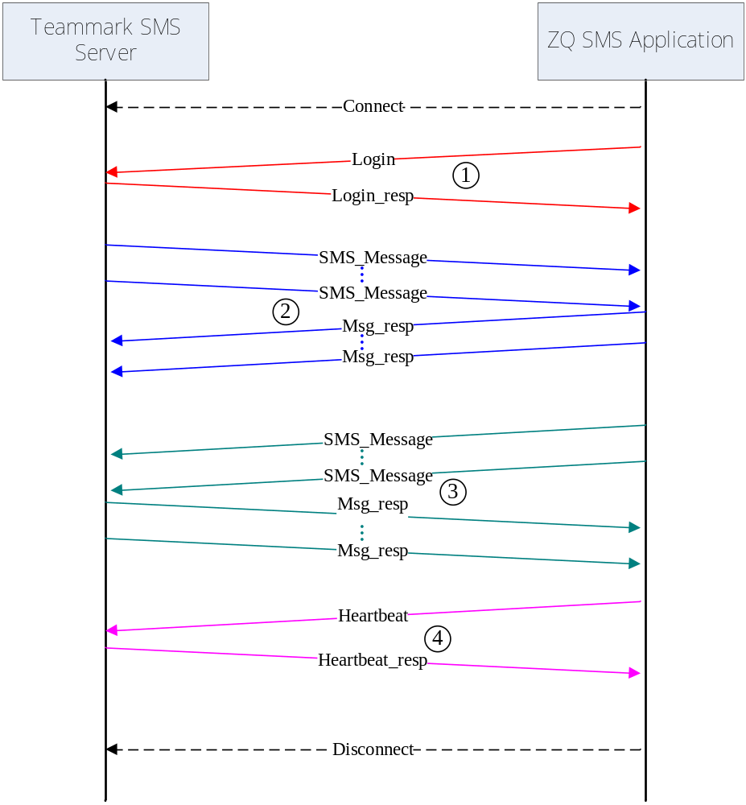
Figure 1

Architecture

Architectural Goals and Constraints
Because a successful order operation needs some steps, so SMSService’s function is concentrated in keeping communications with TM Server or GMS Modem and complete all the steps of a good operation with TICP.

System Logical Structure

Overview
The logical decomposition of this system and its context, described as package / module diagram as well.

System Hierarchy
Following figure 2 is the detail architecture of SMS-Gateway. Figure 3 is the detail architecture of SMS-Modem. In fact, these two versions are much similar in logic work flow.
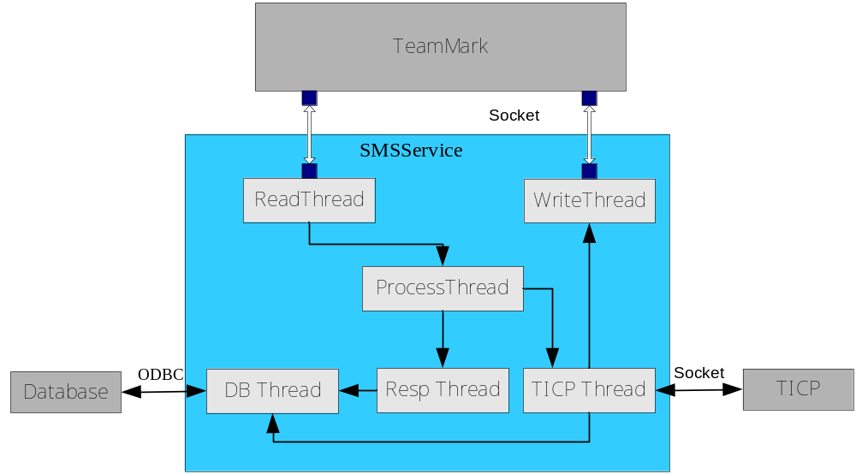
Figure 2 SMS-Gateway System Hierarchy
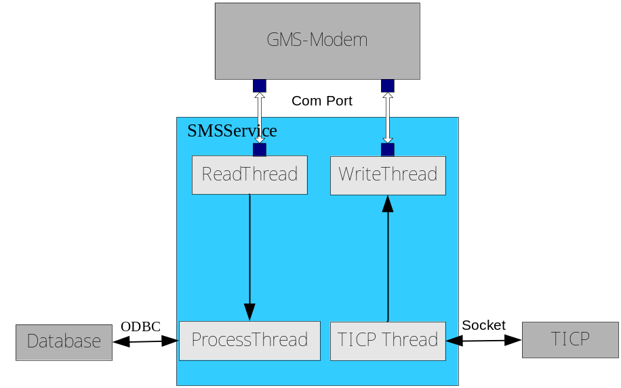
Figure 3 SMS-Modem System Hierarchy

Architecturally Significant Design Packages
2.2.3.1 Common Module
NPVRSocket
  - Encapsulate socket API.
TicpProc
  - Initialize/Uninitialize the Socket communication with TICP Server.
  - Send data to TICP Server, receive data from TICP Server and complete all services with TICP.
  - Return value is Ticp Server Processed result.
SMSDB
  - Encapsulate ODBC API.
2.2.3.2 SMS-Gateway
SMSService
  - Initialize/Uninitialize the Socket communication with TM Server.
  - Set the Socket Configuration.
  - Create only one Socket handle and connect with TM Server.
ReadThread
  - Read raw messages form TM Server.
  - Put the raw messages into the queue of ProcessThread.
  - Count time.
  - Take charge of re-connecting.
WriteThread
  - Write feedback messages to TM.
ProcessThread
  - Create a RespThread and some TICPThread.
  - Parse and classify the raw messages and put them to a real process thread.
RespThread
  - Deal with resp messages.
  - Store sended messages and verify these messages whether they are verified.
  - Call DBThread’s function to update database.
TICPThread
  - Deal with raw messages.
  - Create and send XML files included the content of messages to TICP.
  - Receive the response from TICP and create and put a message to the queue of WriteThread.
  - Call DBThread’s function to insert data to database.
DBThread
  - Insert and update data into database.
2.2.3.3 SMS-Modem
SMSService
  - Initialize/uninitialize the Com communication with GMS-Modem.
  - Set the Com Port Configuration.
  - Create only one Com handle and connect with GMS-Modem.
ReadThread
  - Read raw messages form GMS-Modem
  - Put the raw messages into the queue of ProcessThread.
  - Count time.
WriteThread
  - Write feedback messages to GMS-Modem.
ProcessThread
  - Create a RespThread and some TICPThread.

Error Handling and Fail-Over
This section describes the error handling method on the system architecture level.
2.3.1 SMS-Gateway
- Failed to initialize the communication between TM Server
In this situation, SMS-Gateway does nothing (such as socket error), just keep re-trying to connect periodically. The SMS-Gateway is still in running status.
- Failed to initialize the communication between TICP
In this situation, SMS-Gateway does nothing (such as socket error), just keep re-trying to connect in some times. The SMS-Gateway is still in running status.
- Failed to receive any data from TM
In this situation, SMS-Gateway sends a heartbeat to TM, and if failed to receive the heartbeat response in some time, SMS-Gateway reconnect the TM Server.

    - SMS-Modem
1. Failed to initialize the Com Port
In this situation, SMS-Modem does nothing(Com port is occupied by other application), just record error in log file.
2. Failed to read and write Com Port
In this situation, SMS-Modem re-initialize Com Port.

Static Class View
This section describes the primary classes and their static relationship.
3.1 SMS-Gateway Class View
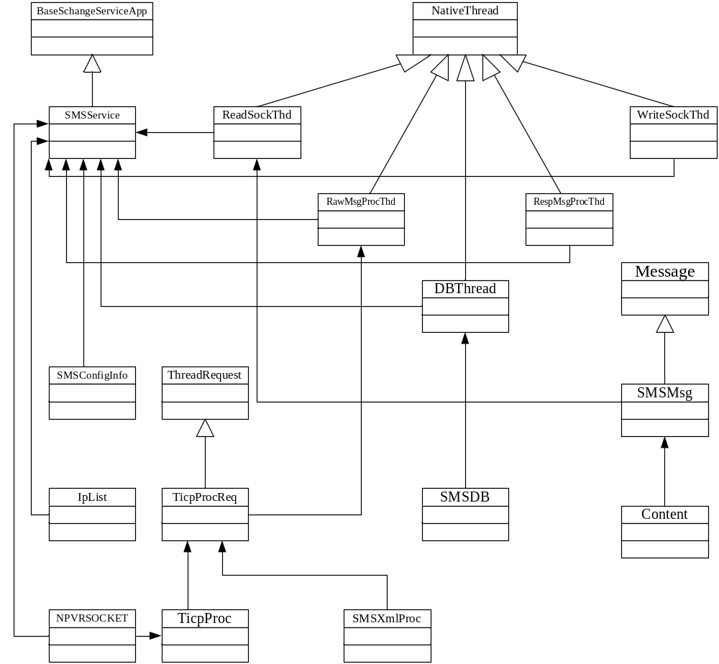
Figure 4 SMS-Gateway Class View
3.2 SMS-Modem Class View
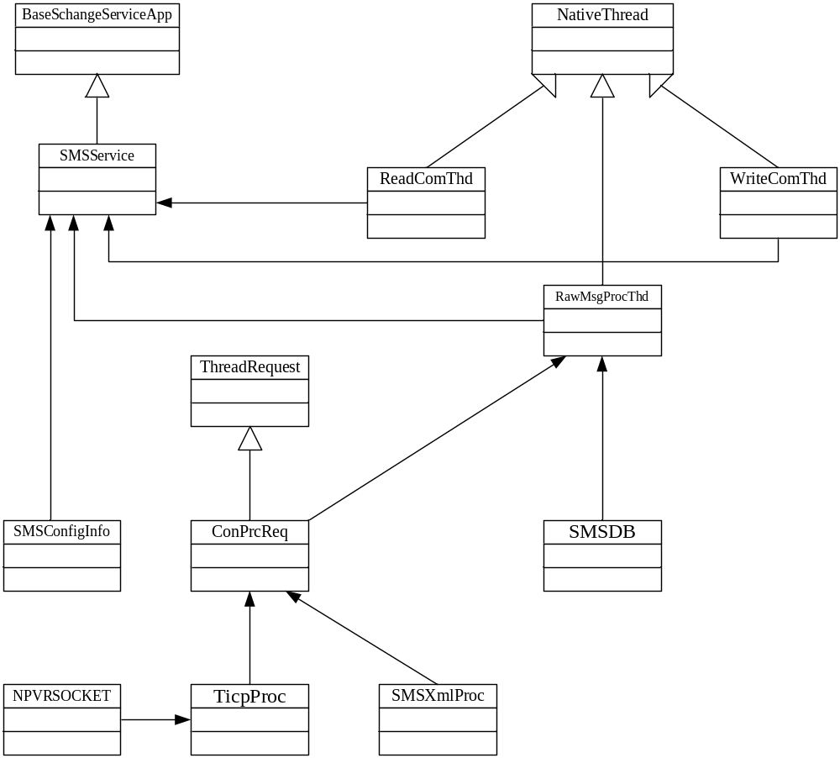
Figure 5 SMS-Modem Class View

The NPVRSocket, TicpProc, SMSXmlProc and SMSConfigInfo modules are common modules in SMS-Modem and SMS-Gateway version.

System Sequence View

Sequence Diagram

4.1.1 SMS-Gateway Sequence Diagram
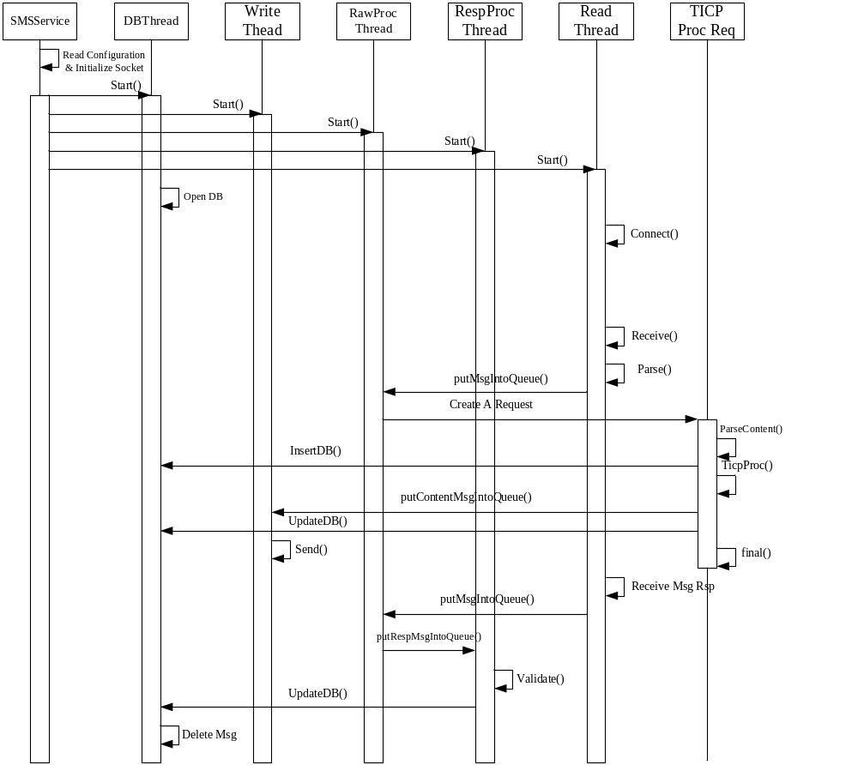
Figure 6 SMS-Gateway Sequence Diagram

4.1.2 SMS-Modem Sequence Diagram
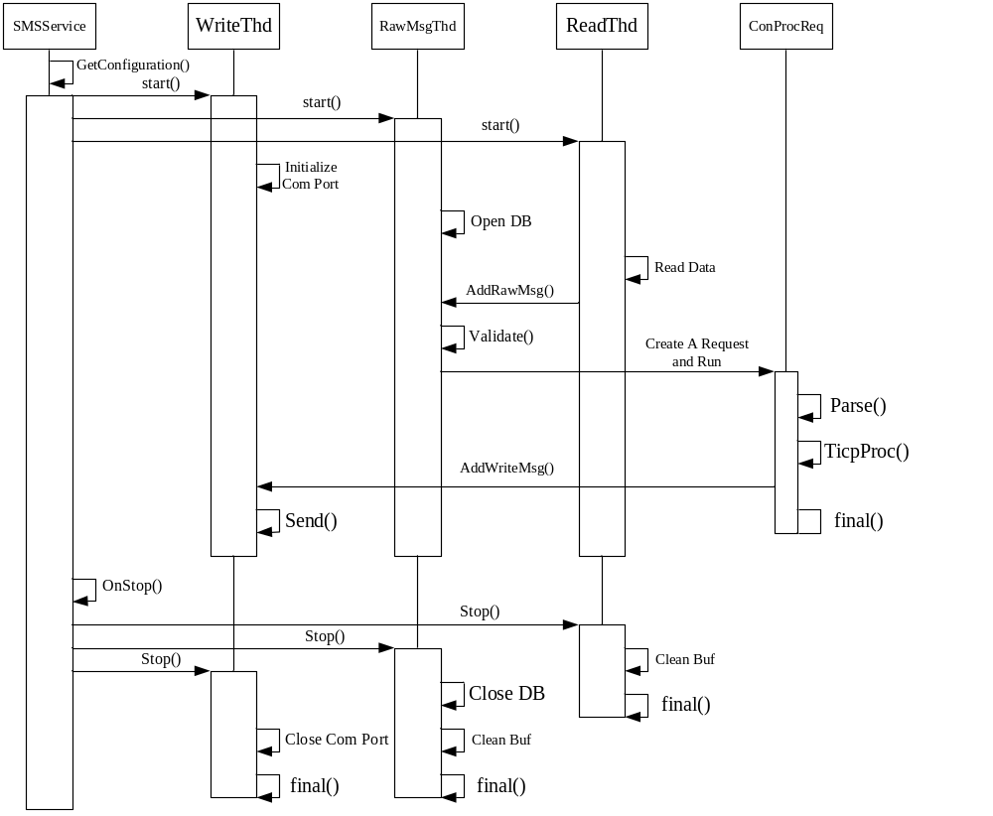
Figure 7 SMS-Modem Sequence Diagram

Configuration
This section provides the information of system’s parameters, value and effect.

5.1 SMS-Gateway configuration

5.1.1 SMS-Gateway configuration in registry
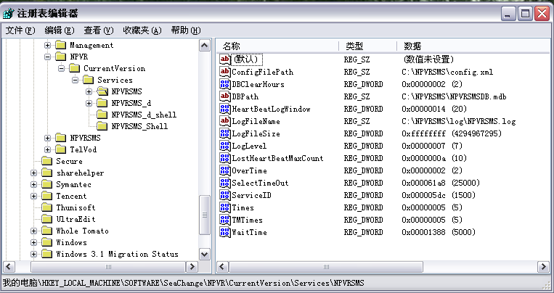
Installshield will set default value of the SMS-Gateway(NPVRSMS) automatically.
HKEY_LOCALMACHINE\Software\Seachange\NPVR\CurrentVersion\Services\
Configuration | Content | Default value
ConfigFilePath | Path of config file | C:\NPVRSMS\config.xml
DBClearHours | Every a few hours DB clean | 2
DBPath | Path of Database | C:\NPVRSMS\NPVRSMSDB.mdb
HeartBeatLogWindow | Every a few times log a heatbeat record | 20
LogFileName | Path of Log File Name | C:\NPVRSMS\log\NPVRSMS.log
LogFileSize | Size of Log File | 0xffffffff
LogLevel | Level of Log File | 7
LostHeartBeatMaxCount | Heart Beat max lost permitted count | 10
overtime | Short message max over time in hours | 2
SelectTimeOut | Max Time of wait for TICP in milliseconds | 25000
ServiceID | ID of server | 0
Times | Times of do operation with Ticp | 5
TMTimes | Times of do operation with TM Server | 5
Wait Time | Time of waiting for messages from TM | 5

5.1.2 SMS-Gateway configuration in Config Xml
Always, this xml file is in the setup path of SMS-Gateway, and always is set automatically.

5.1.2.1 TICP Server IP address and port
<TICP>
<Ip address="10.9.0.101" port="61233" />
<Ip address="10.9.0.101" port="61233" />
</TICP>

5.1.2.2 SMS Server IP address and port
<SMServer>
<Ip address="211.147.224.131" port="9212" />
</SMServer>

5.1.2.3 ON_OFFs
<ON_OFF>
<Response Flag="1" />
<ErrorResponse Flag="1" />
<ReplyHistory Flag="1" />
</ON_OFF>

5.1.2.4 ACTION which are services supported by TICP
<ACTION>
<RegisterControl Flag="RG" />
<StreamControl Flag="AC" />
<ChatControl Flag="LT" />
<NickNameControl Flag="10" />
</ACTION>

5.1.2.5 Stream Controls which SMS content is in received messages and Ticp content is sent to TICP Server.
<StreamControl>
<PlayFlag SMS="play" Ticp="91" />
<StopFlag SMS="stop" Ticp="92" />
<FastForwardFlag SMS="ff" Ticp="93" />
<FastRewindFlag SMS="fr" Ticp="94" />
<PauseFlag SMS="pause" Ticp="95" />
<ResumeFlag SMS="resume" Ticp="96" />
</StreamControl>

5.1.2.6 SMS Providers which PHS is 小灵通, mobile is 移动，UNICOM is 联通
<SMSProvider>
<PHS SP="1234" ZipCode="021"/>
<MOBILE SP="yidong" ZipCode=""/>
<UNICOM SP="lianton" ZipCode=""/>
</SMSProvider>

5.1.2.7 Return Text which ActionCode is returned by TICP and text is corresponding content in Chinese.
<ReturnText>
<TICP ActionCode="0" text="操作失败" />
<TICP ActionCode="1" text="操作成功" SuccessFlag="1" />
<TICP ActionCode="3" text="号码已邦定，但是需要验证用户名和密码" />
<TICP ActionCode="4" text="号码没有权限" />
<TICP ActionCode="5" text="号码未邦定，需要验证用户名和密码" />
<TICP ActionCode="6" text="点播失败" />
<TICP ActionCode="7" text="点播的节目不存在" />
<TICP ActionCode="8" text="点播人数过多，请稍候再播" />
<TICP ActionCode="9" text="点播费用不够" />
<TICP ActionCode="10" text="点播节目总数错误" />
<TICP ActionCode="11" text="你已取消节目" />
<TICP ActionCode="12" text="非法节点群号，无法激活STB" />
<TICP ActionCode="13" text="不正确的入场券，播放失败" />
<TICP ActionCode="14" text="节目不存在或者节目状态错误，播放失败" />
<TICP ActionCode="15" text="播放失败" />
<TICP ActionCode="16" text="停止播放失败" />
<TICP ActionCode="17" text="快进失败" />
<TICP ActionCode="18" text="重看失败" />
<TICP ActionCode="19" text="暂停失败" />
<TICP ActionCode="20" text="继续播放失败" />
<TICP ActionCode="21" text="前跳失败" />
<TICP ActionCode="22" text="后跳失败" />
<TICP ActionCode="23" text="没有找到有效的连接" />
<TICP ActionCode="24" text="无法到达指定的时间点" />
<TICP ActionCode="25" text="视频流未开始无法控制视频流" />
<TICP ActionCode="26" text="视频流已结束无法控制视频流" />
<TICP ActionCode="27" text="视频流出错" />
<TICP ActionCode="31" text="录制成功" SuccessFlag="1" />
<TICP ActionCode="32" text="节目正在播出，无法录下全部节目" />
<TICP ActionCode="33" text="节目结束，无法录制" />
<TICP ActionCode="34" text="录制失败" />
<TICP ActionCode="35" text="系列录制成功" />
<TICP ActionCode="36" text="删除成功，由于节目没有录制缴费取消" />
<TICP ActionCode="37" text="删除成功，由于节目录制成功缴费操作将执行" />
<TICP ActionCode="38" text="删除成功，余下的节目不会再录制" />
<TICP ActionCode="39" text="费用不够，无法录制" />
<TICP ActionCode="40" text="删除成功，节目没有录制缴费取消" />
<TICP ActionCode="41" text="删除成功，节目录制缴费操作将执行" />
<TICP ActionCode="42" text="节目还没播放，录制已满" />
<TICP ActionCode="43" text="删除失败处理" />
<TICP ActionCode="44" text="删除失败入场券" />
<TICP ActionCode="45" text="无法激活不存在的STB" />
<TICP ActionCode="46" text="无法激活，因为不是指定的用户" />
<TICP ActionCode="47" text="无法激活，因为序列号超过最大值" />
<TICP ActionCode="48" text="无法激活，因为用户不存在" />
<TICP ActionCode="49" text="已激活" />
<TICP ActionCode="51" text="无法聊天" />
<TICP ActionCode="52" text="您的输入有误，请检查后重新发送" />
<TICP ActionCode="71" text="注册失败, 没有找到用户" />
<TICP ActionCode="72" text="注册失败" />
<TICP ActionCode="50" text="系统出错,无法操作" />
<TICP ActionCode="73" text="视频流正在重连中,操作失败" />
<TICP ActionCode="74" text="注册昵称失败" />
<TICP ActionCode="75" text="用户不存在,注册昵称失败" />
<TICP ActionCode="76" text="昵称已存在,注册失败" />
<TICP ActionCode="77" text="昵称不合法,注册失败" />
<TICP ActionCode="78" text="取消昵称失败" />
<TICP ActionCode="79" text="用户不存在,取消昵称失败" />
<TICP ActionCode="80" text="昵称不存在,取消昵称失败" />
<TICP ActionCode="81" text="发送消息失败" />
<TICP ActionCode="83" text="消息被拒绝,发送失败" />
<TICP ActionCode="82" text="用户不存在,发送失败" />
</ReturnText>

5.2 SMS-Modem configuration
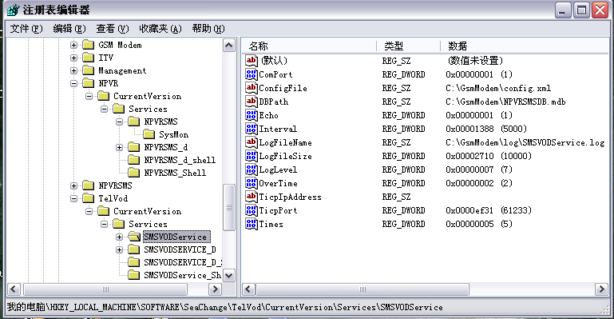
Installshield will set default value of the SMS-Modem automatically.
HKEY_LOCALMACHINE\Software\Seachange\ITV\CurrentVersion\Services\
Configuration | Content | Default value
ComPort | ComPort | 1
ConfigFilePath | Path of config file | C:\GmsModem\config.xml
DBPath | Path of Database | C:\GmsModem \NPVRSMSDB.mdb
Echo | Whether Gms-Modem return information when send information to it | 1
LogFileName | Path of Log File Name | C:\NPVRSMS\log\NPVRSMS.log
LogFileSize | Size of Log File | 0xffffffff
LogLevel | Level of Log File | 7
Interval | Every a few milliseconds SMS-Modem send info to Modem | 5000
overtime | Max Time of wait for TICP in milliseconds | 5000
TicpIpAddress | IP Address of Ticp
TicpIpPort | IP port of Ticp | 61233
Times | Times of do operation with Ticp | 5

Object Design
This section provides the information of object’s properties and attribute definition.

Common Object

NPVRSocket
This object is an encapsulation of windows socket.
- Attribute list
NAME | Type | DESCRIPTION
m_socket; | SOCKET | The client handle of socket.
m_addr; | SOCKADDR_IN | The address of socket.
m_hSocket; | SOCKET | The server handle of socket.
- Operation List
NAME | DESCRIPTION
bool InitialSocket(); | Initialize socket.
bool Connect(int port, char* ip); | Connect to server.
bool SendC(char* buf, int bufLen); | Send data to server.
bool RecvC(char* buf, int bufLen); | Receive data from server.
bool WSASelectC(WSAEVENT& hWSAEvent, long lNetworkEvents); | Select mode of socket on client and which events will be answered.
bool SelectC(DWORD timeout); | Set how much time to wait.
long GetNetworkEventC(WSAEVENT& hWSAEvent); | Get which event is actived.
bool CloseSocketC(); | Close socket client handle.
bool Listen(int port); | Listen to a port.
bool Accept(); | Accept a connection from a client
bool SendS(char* buf, int bufLen); | Send data to client
bool RecvS(char* buf, int bufLen); | Receive data from client.
bool WSASelectS(WSAEVENT& hWSAEvent, long lNetworkEvents); | Select mode of socket on server and which events will be answered.
bool CloseSocketS(); | Close socket server handle.

SMSDB
This object is an encapsulate of odbc.
- Attribute list
NAME | Type | DESCRIPTION
m_pConnection | _ConnectionPtr | Connection pointer
m_pRecordset; | _RecordsetPtr | Recordset pointer
- Operation List
NAME | DESCRIPTION
bool ConnectDB(char* path, WCHAR* error); | Connect to DB.
bool Insert(); | Insert data to DB.
bool UpdateState(); | Update data to DB.
bool SelectUnfinished(char* time, WCHAR* sErr); | Select unfinished data from DB according to parameter time.
bool SelectPart(char* time, WCHAR* sErr); | Select a part of data from DB according to parameter time.
int GetUID(); | Get uid from DB.
bool DeleteOverdueMessage(char* time); | Delete data in DB according parameter time.

SMSConfigInfo
- Attribute list
NAME | Type | DESCRIPTION
_configFilePath[MAX_PATH + 1]; | char | Path of config file
_TicpIplist | CStringList | List of TICP Server IP address
_TicpPortlist | CStringList | List of TICP Server IP port
_TMFlagList | CStringList | List of message flags from TM
_TicpFlagList | CStringList | List of message flags to TICP
_ActionCodeList | CStringList | List of Action Code
_ReturnTextList | CStringList | List of return text
_SPList | CStringList | List of Service Provider
_SPNumberList | CStringList | List of Service Provider Number
_ACFlag[10] | char | Flag of order
_CTFlag[10] | char | Flag of chat
_RGFlag[10] | char | Flag of register
_NCFlag[10] | char | Flag of nickname
_TMIp[20] | char | Ip address of TM Server
_TMPort | DWORD | Ip port of TM Server
_response | DWORD | Whether response.
_errorResponse | DWORD | When operate fail whether reponse.
_replyHistory | DWORD | When response whether include message received.
_success[MAX_LENGTH]; | Int | Success flag to return code

SMSXmlProc
- Attribute list
NAME | Type | DESCRIPTION
init | ZQ::common::ComInitializer*
- Operation List
NAME | DESCRIPTION
void XmlProc | Get data from a xml file
bool XmlGetConfig(SMSConfigInfo* info); | Get configuration from config xml file.

TicpProc
- Attribute list
NAME | Type | DESCRIPTION
m_pXmlProc | SMSXmlProc | The variable which process xml
m_pTicpSocket | NPVRSocket* | NPVRSocket pointer
- Operation List
NAME | DESCRIPTION
int TicpProcess(int mode, char* phoneNumber, int sequenceID, char* sendTime, char* content); | Process TICP operation.
bool sendPlay(); | Send order xml files.
bool sendChat(); | Send chat xml files.
bool sendRegister(); | Send register xml files.
bool sendNickName(); | Send nickname xml files.
bool SendAndRecv(char* xmlfile, char* returnXmlfile); | Send xml files and receive result xml files.

SMS-Gateway objects

ReadThread
This class is an encapsulation of a received messages from TM.
- Attribute list
NAME | Type | DESCRIPTION
m_pNSocket | NPVRSocket* | The point of NPVRSocket
m_pService | SMSService* | The pointer of main thread.
- Operation List
NAME | DESCRIPTION
void ReConnect(); | Re-connect to TM Server.
bool sendLoginMsg(); | Send log message to TM Server.
void Classify(int packagelength, int cmd, int uid, char* content); | Parse and classify the received messages.

ProcessRawMsg
This class encapsulates the operation with RawMessage.
- Attribute list
NAME | Type | DESCRIPTION
m_queueMsg | Queue<SMSMsg> | The memory of storing the raw messages
m_pService; | SMSService* | Pointer to main thread.
- Operation List
NAME | DESCRIPTION
bool ParseRawMessage() | Parse raw messages in queue, and put them into suitable thread.
Void CreateAndSendMsgResponse(LPMessage pMsg); | Create a response message and send it to TM Server.

ProcessRspMsg
- Attribute list
NAME | Type | DESCRIPTION
m_queueRespMsg | queue<LPMessage> | Store response messages.
m_queueContentMSg | queue<LPSMSMSG> | Store content messages.
- Operation List
NAME | DESCRIPTION
void ProcessRespMessage(LPMessage pMsg); | Process response messages.
bool ValidateContentMessage(LPMessage pMsg); | Validate content messages according response messages.

TicpProcessRequest
- Attribute list
NAME | Type | DESCRIPTION
m_pService | SMSService* | The pointer to main thread.
m_pSMSMsg; | SMSMsg* | The pointer to SMSMsg.
m_ticpProc | TicpProc* | The pointer ot TicpProc.
- Operation List
NAME | DESCRIPTION
bool ProcSendContent(); | Process content which want to send;
void LastProcessMessage(); | According to response and errorResponse, put message to WriteThead.

WriteThread
- Attribute list
NAME | Type | DESCRIPTION
m_pService | SMSService* | The pointer to main thread.
m_pNSocket | NPVRSocket* | The pointer to NPVRSocket.
- Operation List
NAME | DESCRIPTION
bool putContentMsgIntoQueue(LPSMSMSG pSMSMsg); | Push content message into queue.
bool putRespMsgIntoQueue(LPMessage pMsg); | Push response message into queue.
void CreateResponse(); | Create response messages.
void CreateContent(); | Create content messages.

SMS-Gateway objects

ReadThread
- Attribute list
NAME | Type | DESCRIPTION
m_pWriteCom | SMSComPortWriteThread* | The pointer to Com Port write Thread.
m_pProcessRawMsg | SMSProcessRawMsgThread* | The pointer to Process Raw Message Thead.
m_dataBuffer[1024] | char | Buffer to receive messages.

WriteThread
- Attribute list
NAME | Type | DESCRIPTION
m_QueueWriteMsgStr | STRCMDQUEUE | Buffer to store messages.
m_pSMSSrv; | SMSService* | The pointer to main thread.
- Operation List
NAME | DESCRIPTION
void AddWriteMsg(string msg); | Put message into queue.

ProcRawMsgThread
- Attribute list
NAME | Type | DESCRIPTION
m_pService | SMSService* | The pointer to main thread.
m_QueueRawMsgStr | CMDSQUEUE | Buffer to receive raw message.
m_db | SMSDB* | The pointer to SMSDB.
- Operation List
NAME | DESCRIPTION
void InitializeSMSModem(); | Initialize GMS-Modem.
void ProcessSMSComeFlag(const char* pRawMsg); | Process Gms-Modem about data coming flag.
void ProcessSMSContent(const char* pRawMsg); | Process Gms-Modem about data readingflag.
void ProcessSMSListCmd(const char* pRawMsg); | Process Gms-Modem about data list flag

ContentProcessReq
- Attribute list
NAME | Type | DESCRIPTION
m_pService | SMSService* | The pointer to main thread.
m_pRawMessage | SMSProcessRawMsgThread* | The pointer to processing raw message thread.
m_pComWrite | SMSComPortWriteThread* | The pointer to writing com port thread.
m_db | SMSDB* | The pointer to SMSDB.
m_ticpProc | TicpProc* | The pointer to TicpProc.
- Operation List
NAME | DESCRIPTION
bool ParseMsgAndJudgeProcess(); | Parse message and judge how to process.
bool DecodeUnicode(); | Decode messages with Unicode.
bool DecodeUTF7(); | Decode messages with UTF7.
void deleteSMS(); | Delete messages in GMS-Modem.
bool CodingUnicode(); | Code messages in Unicode.
void CreateCmd(); | Create command.

